CIS 41A - Lab 4: Classes, inheritance, and review of iterables and exception handling

Convert Lab 3 into an OOP program and add more features to the application.   
The application will be in 2 files: language.py and lab4.py

**language.py**

Description of classes

There are 3 classes in language.py: a Language superclass and 2 subclasses: LanguageFile and LanguageUI  
- The Language superclass contains data that are read in from the input lab3.txt file  
- The LanguageFile subclass writes data to a file.

- The LanguageUI subclass interacts with the user and prints data to screen.

You should re-use some of the code of lab 3 by putting the functions of lab 3 into one of the 3 classes.

It is highly recommended that you do unit test of each class before writing the next class.

Language superclass:

* Create a class attribute called DEFAULT_FILE that stores the lab3.txt filename.
* Read data from the DEFAULT_FILE and store data. You should re-use code from lab 3.
* The Language class does not interact with the user, which means there's no user input or printing to screen.

LanguageFile subclass, derived from the Language class:

* Has a method to print to file the list of the most common languages (same functionality as in Lab 3).
  + The method has a required input argument, which is a filename.
* Has a method to print to file all the countries, or all the languages, or both.
  + The method has a *required* input argument, which is a filename, and an *optional* input argument, where the user can enter either "country" or "language" or nothing. If the user enters nothing, it means they want both country and language.
  + If the choice is "country", print to the file that's passed in as input argument:
    - The number of countries
    - The list of all countries. Each line of the listing is one letter of the alphabet, starting with 'A' and ending with 'Z'. The countries on each line are in alphabetical order and are separated by comma. The lines of data are separated by a blank line. (See sample output.)
  + If the choice is "language", print to the file that's passed in as input argument:
    - The number of languages
    - The list of all languages. Each line of the listing is one letter of the alphabet, starting with 'A' and ending with 'Z'. The languages on each line are in alphabetical order and are separated by comma. The lines of data are separated by a blank line. (See sample output.)
  + If the choice is not valid:
    - Print an error message and don't write to any file.
* *1pt EC if the method doesn't have 2 practically identical blocks of code for the 2 grey highlighted parts.*

LanguageUI subclass, derived from the Language class:

* Has a private method that lets the user enters 2 or more country languages (same functionality as in Lab 3), but with the following additional features:
* Instead of making the user enter the full name of the country, ask the user for a letter, then print the list of country names starting with that letter and print a corresponding counting number, one for each country name. (See sample output.)
* Ask the user to choose a number (which means the user indirectly chooses a corresponding name).  
  If the user doesn't enters a number within range, keep prompting until you get a valid number.  
  Hint: It's simpler to put the code of this step in a separate private method.
* Keep running the previous 2 steps until you get at least 2 valid countries and the user has pressed the Enter key to stop. (Same requirement as in Lab 3.)
* Has a method that prints the common language among the chosen countries, and print all languages from the chosen countries (same output as Lab 3.)

**lab4.py**

The file lab4.py is works with the LanguageFile and LanguageUI classes. Write code to:

* Create a LanguageFile object
* Call the method to print all countries to a file, use any filename you like
* Call the same method to print all languages to a file, use any filename you like
* Call the same method to print both countries and languages to a file, use any filename you like
* Call the method to print most popular languages to a file, use any filename you like
* Create the LanguageUI object
* Loop to keep calling the method to let the user compare languages between 2 countries. It's your choice how the user can end the loop, but prompt clearly so the user knows.

Program requirements

* Put a documentation block a the top of *each* source file, with your name and short description of the source file.
* Have a docstring for each public method
* There should be 3 classes in language.py, and they should have the functionality as described above.

To think about before implementing and to review after implementing:

* Choose instance variables and local variables appropriately.
* Remember that all static data structures should be created one time only, don't keep re-creating the same static data structures.
* Any attribute or method that are shared between the 2 subclasses should be put in the superclass.  
  Conversely, any attribute or method that is used by a subclass should only be in the subclass.
* Handle the exception when the input file can't be opened. Keep in mind that the Language class does not send anything to screen or read anything from the keyboard (no user interaction).

Sample output (user input have been changed to red so it's easy to see)

For the LanguageFile class:

1. Output file for choice "country"

Note that countries are in alphabetical order, and it's 1 line per letter of the alphabet, with a blank line in between.

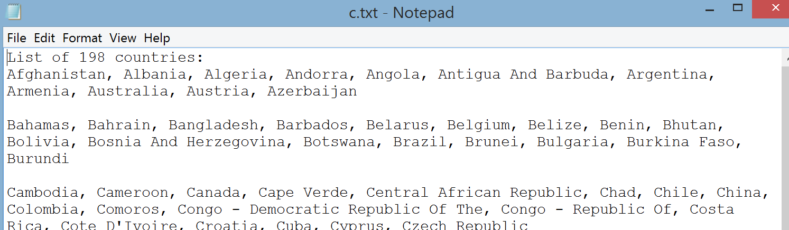

2. Output file for choice "language"

Note that languages are in alphabetical order, and it's 1 line per letter of the alphabet, with a blank line in between.

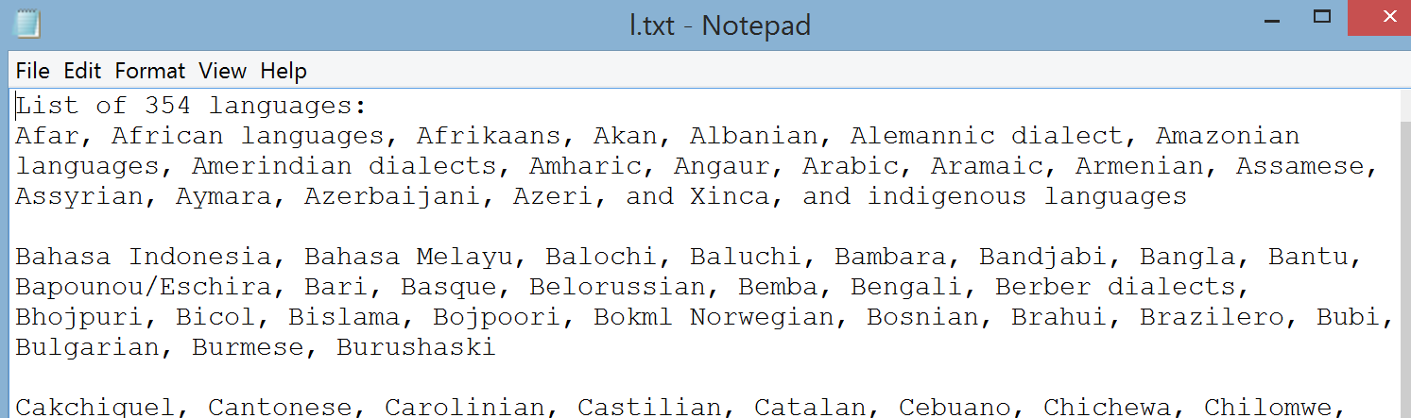

3. Output file for no choice entered:

This screen shot shows the end of the list of countries and immediately following it is the list of languages.

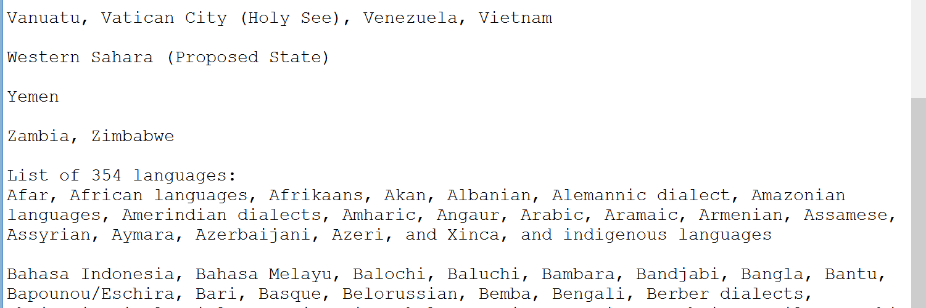

The output file of the most common languages is the same as the lab 3 output.

For the LanguageUI class (user input in green):

Compare languages

Need at least 2 countries

Enter first letter of country name: 22

Input must be a letter

Enter first letter of country name: united states

Input must be a letter

Enter first letter of country name: u

Country names starting with U

1 Uganda

2 Ukraine

3 United Arab Emirates

4 United Kingdom

5 United States

6 Uruguay

7 Uzbekistan

Enter a number corresponding to a country name: a

Input is not a number

Enter a number corresponding to a country name: 55

number is not within range

Enter a number corresponding to a country name: 5

United States chosen

Enter first letter of country name: <enter key>

Need at least 2 countries

Enter first letter of country name: m

Country names starting with M

1 Macedonia

2 Madagascar

3 Malawi

4 Malaysia

5 Maldives

6 Mali

7 Malta

8 Marshall Islands

9 Mauritania

10 Mauritius

11 Mexico

12 Micronesia

13 Moldova

14 Monaco

15 Mongolia

16 Montenegro

17 Morocco

18 Mozambique

19 Myanmar

Enter a number corresponding to a country name: 11

Mexico chosen

Enter first letter of country name: v

Country names starting with V

1 Vanuatu

2 Vatican City (Holy See)

3 Venezuela

4 Vietnam

Enter a number corresponding to a country name: 1

Vanuatu chosen

Enter first letter of country name: <enter key>

No common language

All languages: Bislama English French Mayan Nahuatl Spanish local languages other regional indigenous languages

Continue to compare? y/n: y

Compare languages

Need at least 2 countries

Enter first letter of country name: e

Country names starting with E

1 East Timor

2 Ecuador

3 Egypt

4 El Salvador

5 Equatorial Guinea

6 Eritrea

7 Estonia

8 Ethiopia

Enter a number corresponding to a country name: 1

East Timor chosen

Enter first letter of country name: e

Country names starting with E

1 East Timor

2 Ecuador

3 Egypt

4 El Salvador

5 Equatorial Guinea

6 Eritrea

7 Estonia

8 Ethiopia

Enter a number corresponding to a country name: 3

Egypt chosen

Enter first letter of country name: e

Country names starting with E

1 East Timor

2 Ecuador

3 Egypt

4 El Salvador

5 Equatorial Guinea

6 Eritrea

7 Estonia

8 Ethiopia

Enter a number corresponding to a country name: 8

Ethiopia chosen

Enter first letter of country name: <enter key>

Common language: English

All languages: Amharic Arabic Bahasa Indonesia English French Guaragigna Orominga Portuguese Somali Tetum Tigrigna other indigenous languages

Continue to compare? y/n: n